Comments of the American Chemistry Council
Initiation of Section 301 Investigations: Acts, Policies, and Practices of Certain Economies Relating to Structural Excess Capacity and Production in Manufacturing Sectors

Docket No. USTR–2026–0067
April 15, 2026

The American Chemistry Council (ACC) appreciates the opportunity to comment on the Office of the United States Trade Representative’s (USTR) initiation of investigations under Section 301 of the Trade Act of 1974 regarding structural excess capacity and production in certain manufacturing sectors.

Summary

The U.S. chemical and plastic industry is a true America First policy sector – benefitting from “all in” energy policy, regulatory simplification, and export-driven trade policy. However, excess capacity caused by unfair trading practices from non-market economies (NME) has undermined some critical industrial value chains and has displaced U.S. producers both domestically and in key export markets. Chemical value chains are complicated and broad tariffs or trade defense actions may have unintended consequences that could make the U.S. chemical industry more exposed to such unfair practices. Adopting a value-chain approach to these investigations for the chemical and plastics sector would allow a more precise identification of “at risk” U.S. production while also safeguarding reliable access to raw materials, many of which are essential inputs sourced on market-based terms to sustain U.S. production and exports. ACC and its members stand ready to collaborate closely with USTR on these investigations and have provided specific recommendations that could address genuine concerns and protect U.S. competitiveness, while minimizing unintended consequences and risk of retaliation from any proposed actions.

The U.S. Chemical and Plastics Industry is Impacted by Global Excess Capacity

ACC, a trade association representing more than 190 of America’s leading chemical and plastics companies, values USTR’s recognition of chemicals as a priority industry. ACC particularly appreciates the opportunity to provide input on key investigation priorities as well as data-driven illustrative examples of value chains of industrial over production.

Over the past decade (2014-2024), the U.S. chemical industry invested nearly $320 billion in domestic production and workforce and directly employs over 545,000 highly skilled, highly paid workers, with an additional 5.8 jobs supported for every single chemical industry job. Chemical inputs are essential to U.S. critical value chains with a wide range of chemical products necessary for automotive goods, defense production, pharmaceuticals, semiconductors, and affordable consumer goods. Chemistry represents new innovation – taking waste products and recycling into next generation materials – spurring an entire value chain for investment, technology innovation, and job creation

In 2025, the U.S. chemical industry posted a trade surplus and exported nearly $156 billion, accounting for 9% of all U.S. goods exports, making it the second largest U.S. export manufacturing sector. The U.S. chemical industry has experienced sustained export-led growth over the last decade. However, excess capacity coupled with unfair trading practices affects the ability of U.S. producers to compete domestically and internationally on a level playing field. While not all chemical and plastic value chains are affected by these practices, any proposed actions could affect the larger U.S. chemical industry. ACC therefore strongly recommends these investigations focus on genuine challenges that undermine U.S. investment and innovation, while also ensuring access to key raw material inputs, many of which are not produced in the United States and are necessary to maintain U.S. competitive advantages and export to key markets. Ensuring fair market access and addressing the effects of excess capacity in third country markets is just as important as addressing any domestic effects of global structural excess capacity.

Chart 1: U.S. Chemicals Trade Summary
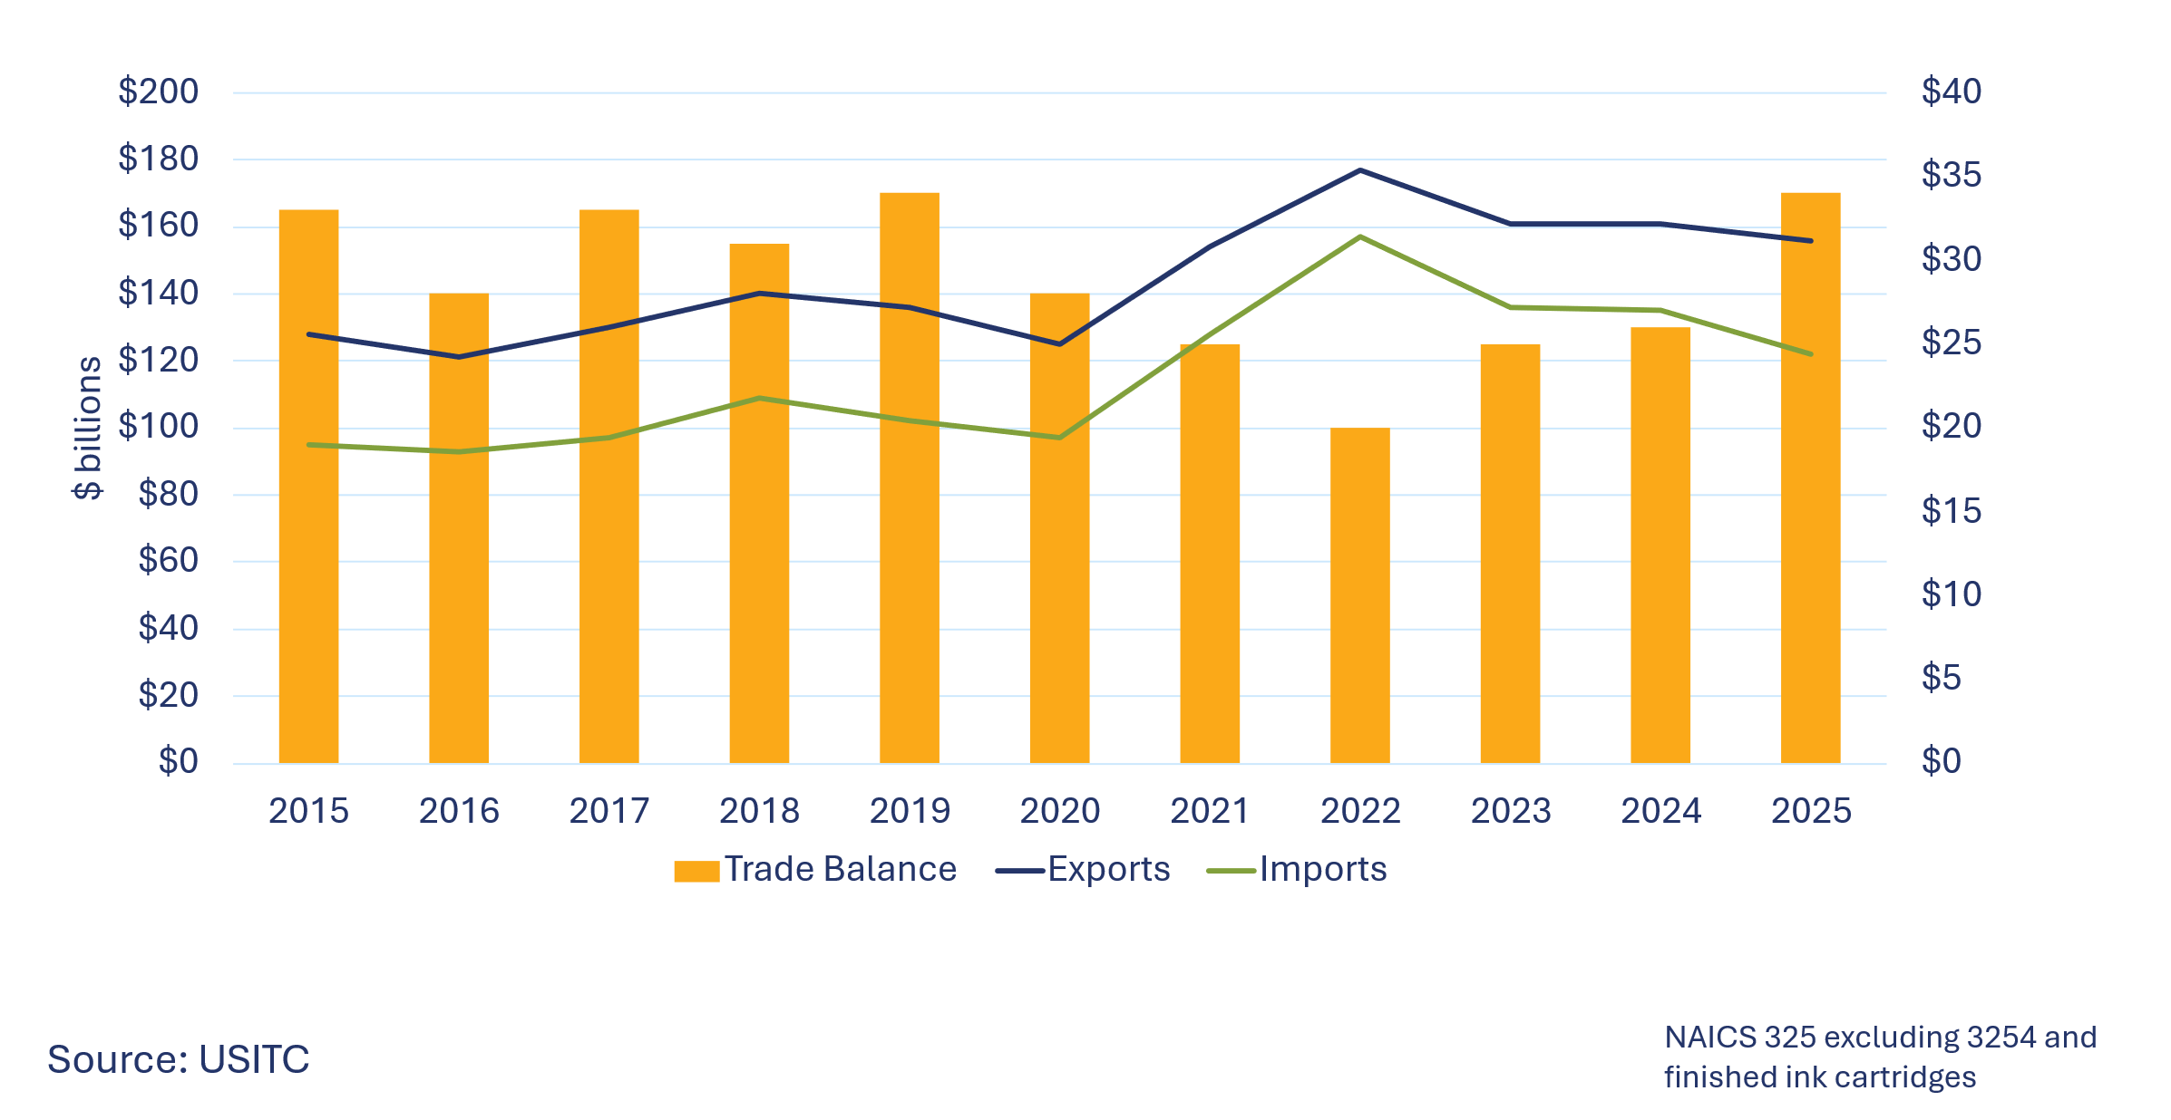

USTR Plays an Important Role in Addressing Global Excess Capacity and Ensuring that U.S. Chemical Companies Remain Competitive
Given the U.S. chemical industry’s important role as an exporter, ACC encourages USTR to lead with proactive trade policies focused on expanding market access to maintain and grow the U.S. chemical industry’s trade surplus in key markets. This includes ensuring access to necessary raw materials and intermediate materials needed for domestic value chains. Trusted commercial and trading partners such as Mexico, Canada, and the European Union often have similar concerns about unfair import competition in certain chemical or plastic value chains and have been developing their own approaches to investigate or respond to structural excess capacity. Opportunities to align measures with such partners on these common concerns would support a comprehensive and effective strategy to address the causes of distortionary global excess capacity including NME subsidies and other unfair practices. A proactive trade policy promoting chemical sectoral agreements that includes regulatory simplification and trade facilitation would further align approaches to common challenges and promote a pro-growth competitiveness agenda that advantages domestic production.
The USMCA Annex on Chemical Substances, also known as the USMCA Chemical Sectoral Agreement, can be a model for this policy approach, leveraging the current template in the existing agreement and further advancing implementation under the current review. Besides aligning approaches on regulatory simplification, trade facilitation, and unfair import competition, a sectoral agreement could also advance new opportunities for U.S. competitive growth into innovative new production. Such a sectoral agreement could be a core component of other bilateral trade deals, such as the Agreements on Reciprocal Trade (ART), building on the template of the USMCA agreement.
These investigations also provide an opportunity to take a comprehensive approach to address systemic challenges of non-market behaviors impacting U.S. industry competitiveness in global markets (e.g., companies benefiting from subsidies, below market returns, use of sanctioned feedstock, etc.) that may be beyond the scope of traditional frameworks such as AD/CVD investigations. These NME practices are often exacerbated by excess capacity transmitted through third countries that act as processing and export platforms, which import low-cost inputs, expand production beyond domestic demand, and redirect output to export markets. This creates a dual impact on U.S. producers: direct import pressure and indirect displacement in third country markets, resulting in reduced export opportunities in other countries, even where demand remains strong.
A Targeted Data Driven Approach is More Likely to Address the Causes of Excess Capacity and Minimize Unintended Consequences and Retaliation

Excess capacity is both a structural issue and a barrier to investment and innovation. It is important to distinguish between cyclical excess capacity – linked to short-term economic fluctuations – and structural excess capacity, which stems from long-term policy and industrial distortions. This would help the investigation distinguish between “business as usual” and excess capacity caused by unfair import competition or trading practices that impact U.S. reindustrialization objectives.
These investigations should also recognize excess capacity as a global issue caused by many factors including sluggish global market conditions and unfair import competition, as well as an asymmetrical trade strategy that restricts imports of raw materials needed to make chemical products while allowing imported chemical goods to unfairly compete. While China is not the only source of excess capacity concerns, China’s share of global commodity chemicals capacity has surged and is projected to increase to 48% by 2030, according to data from ICIS Supply and Demand Database. The same data shows that China’s share of global capacity in specific chemical categories is even higher.
Chart 2: China’s Share of Global Capacity for Basic Chemicals and Plastic Resins

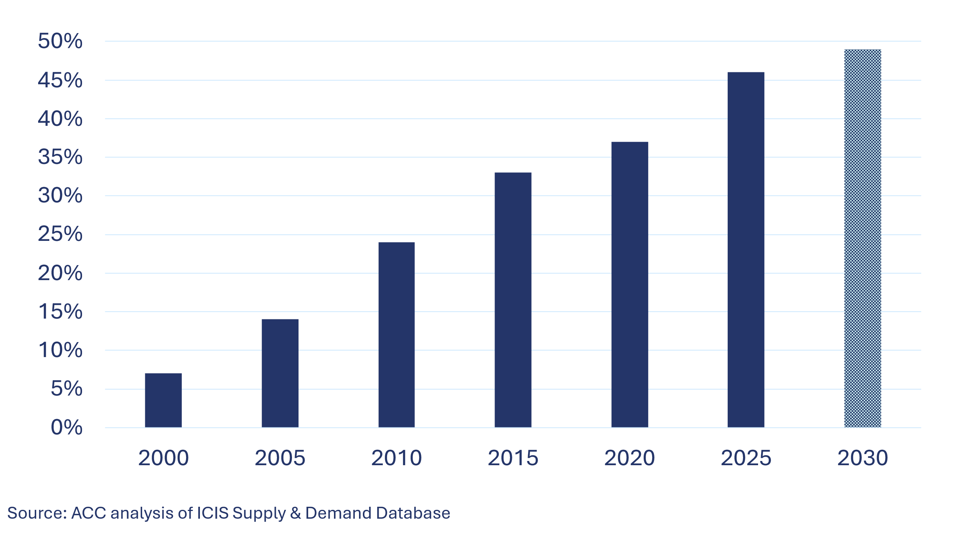
Chart 3: Ratio of Chinese Excess Capacity* to North American Demand
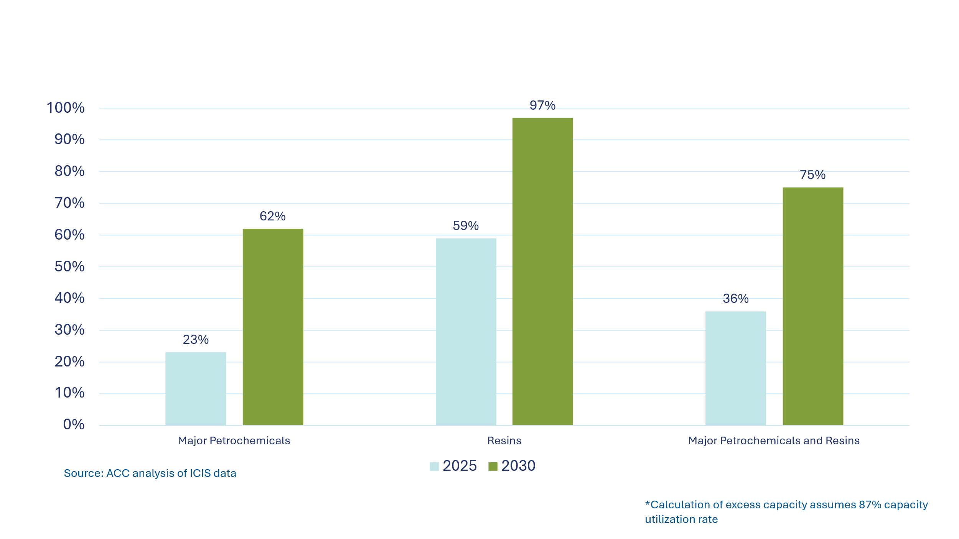
Chart 4: China’s Share of Local Capacity over Local Demand
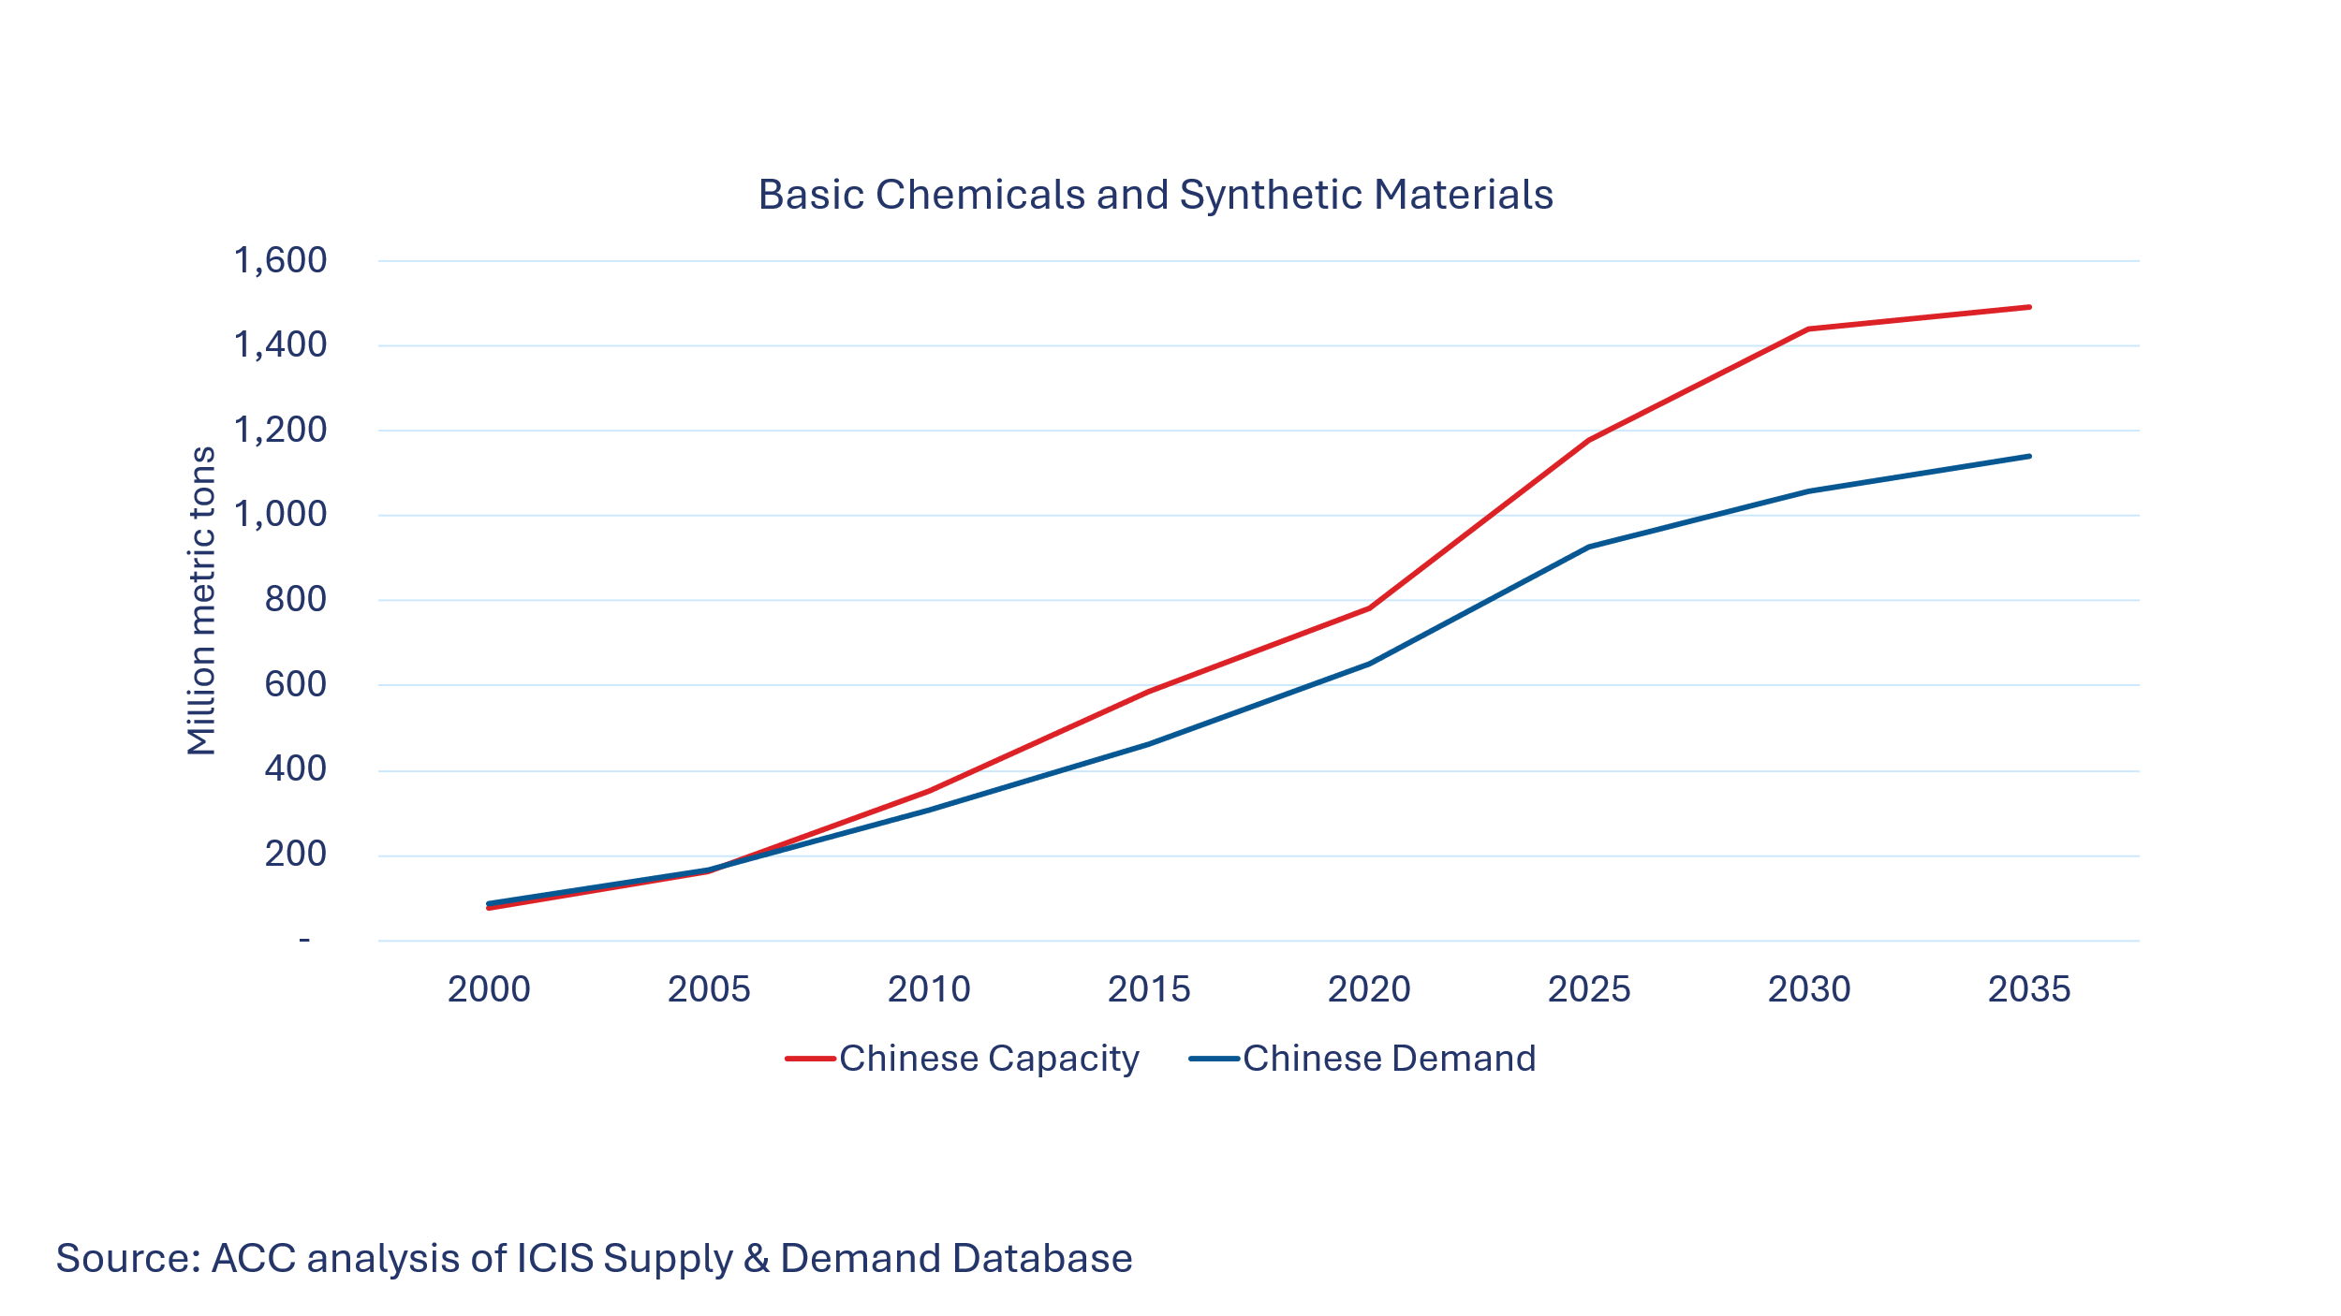
In addition to China’s rapid capacity growth, firms receive considerable government support, and a growing number operate at a loss, creating an unlevel playing field in the global market for chemicals.
Chart 5: Number of Loss-making Firms in China, Source: China National Statistics Bureau (average per month)
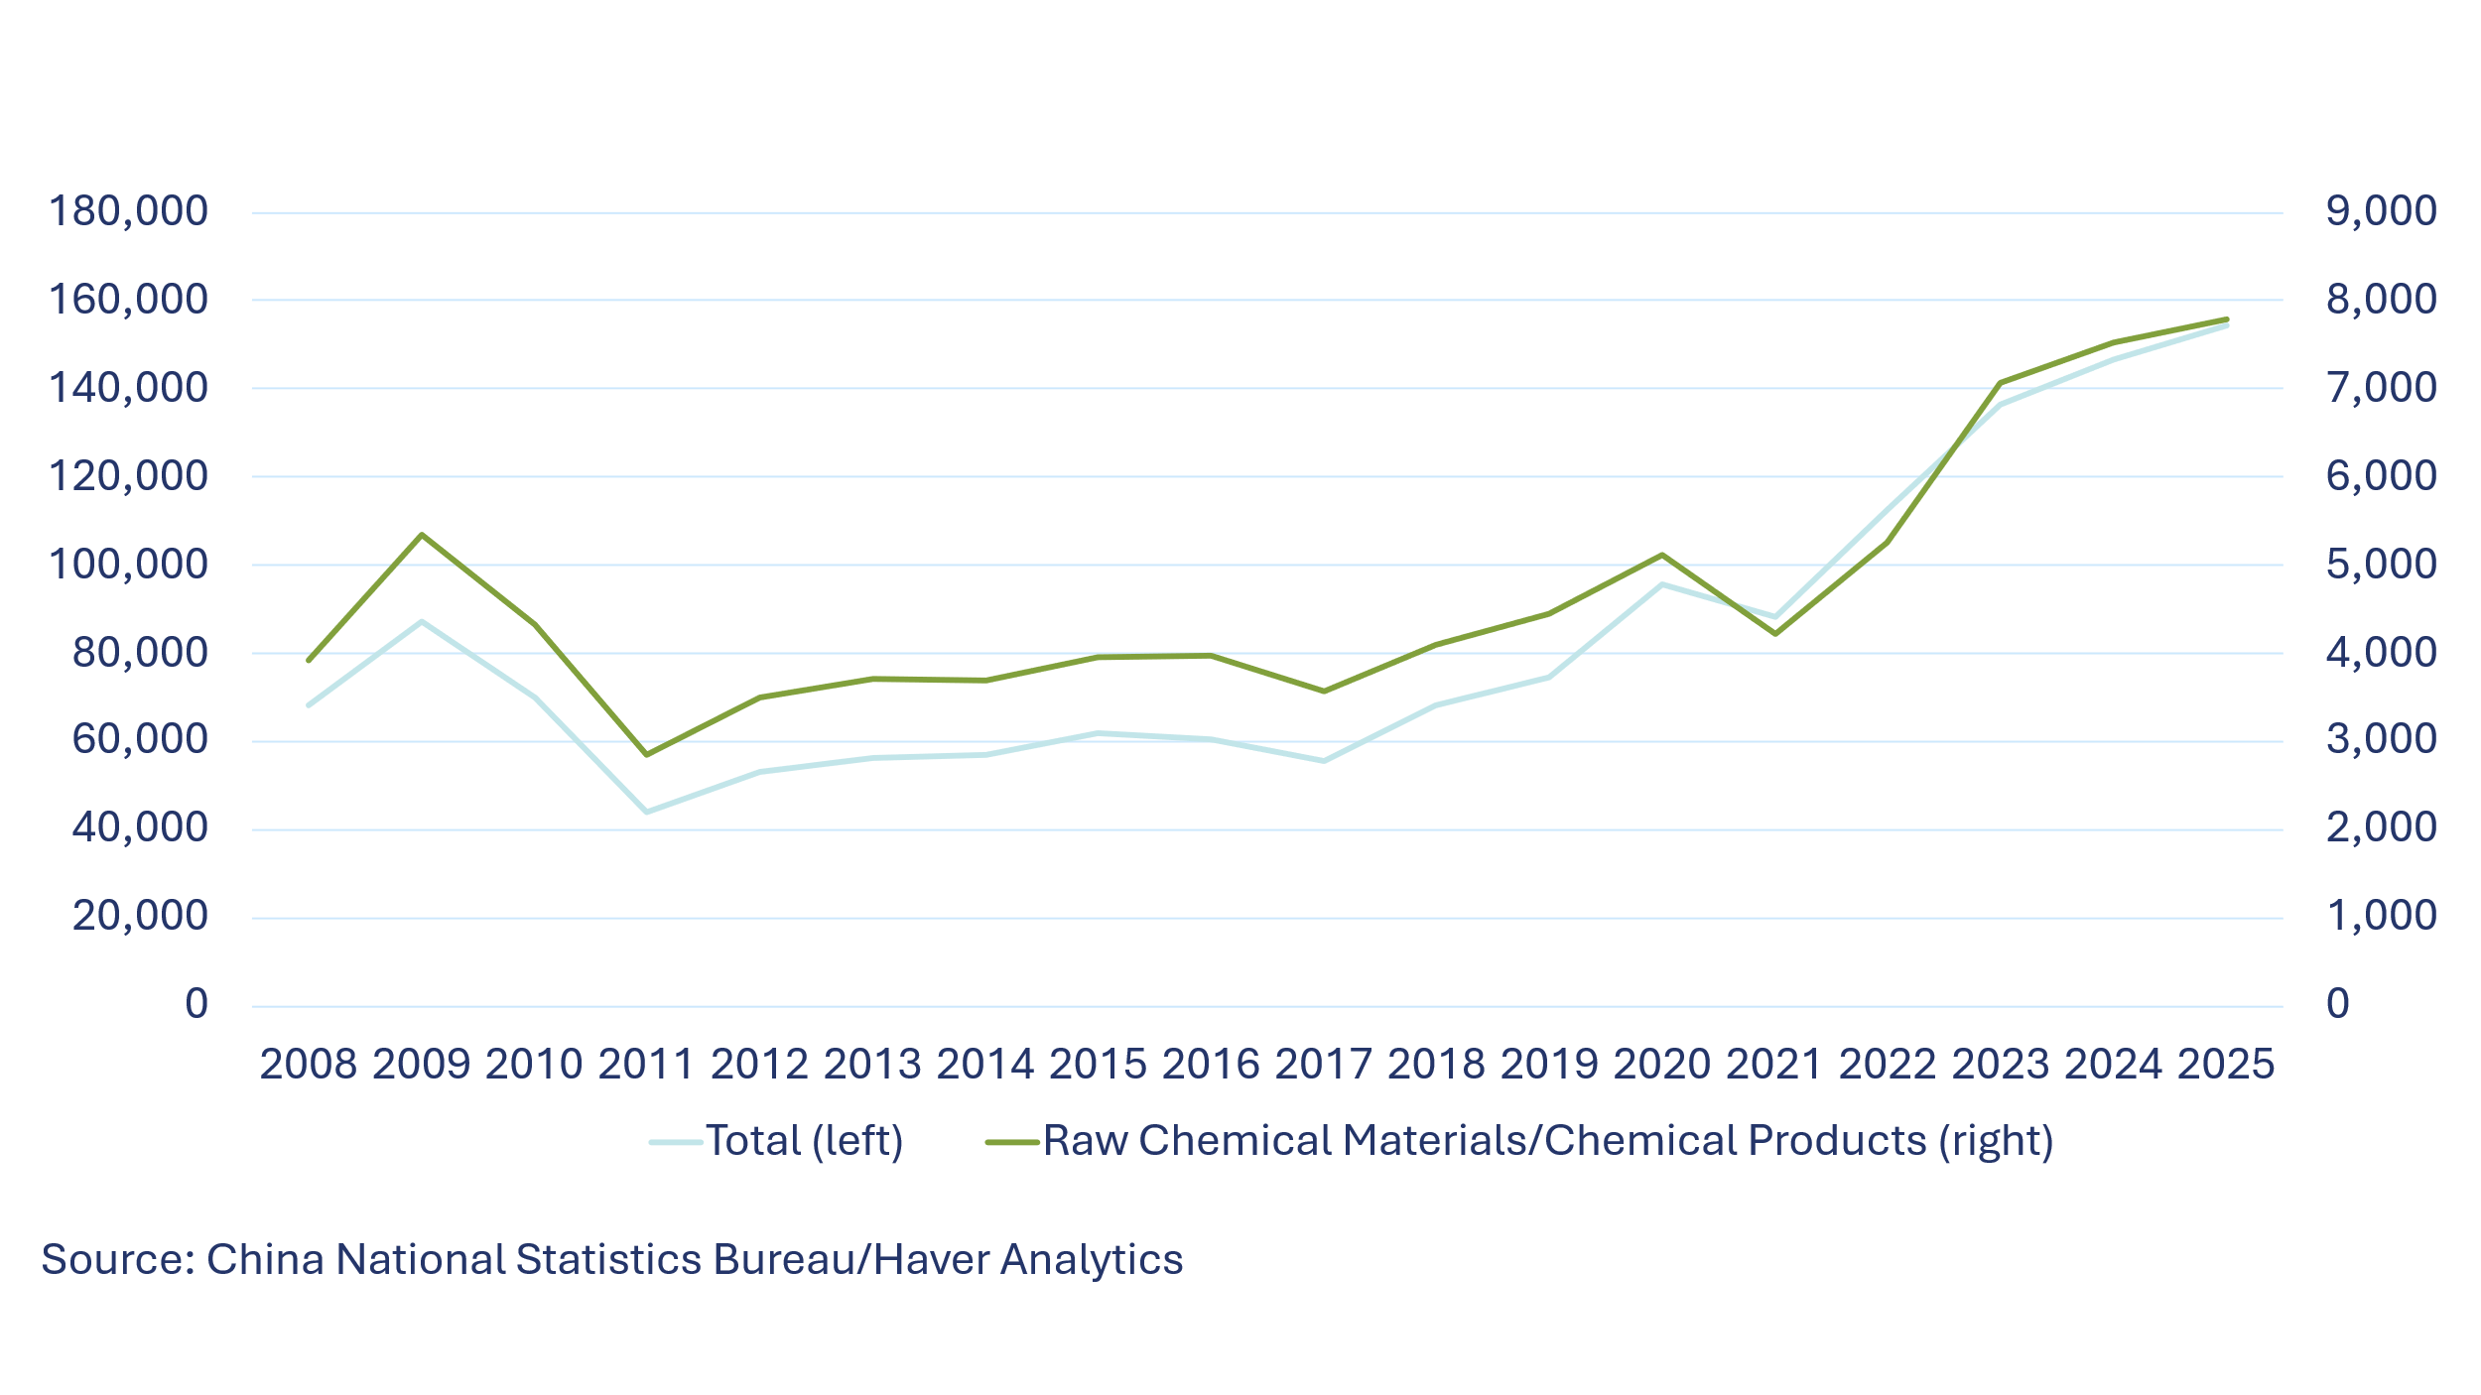
The U.S. chemical industry has long relied on U.S. shale gas production to help maintain our competitiveness, ensuring a reliable supply of competitive feedstock. That competitive edge could be undermined by structural excess capacity caused by unfair trading practices that leads to unfair import competition. However, excess capacity is not solely limited to NME behavior and could also be driven by export-oriented third countries. Therefore, any targeted approach should be inclusive of third country markets where circumvention or transshipment can distort the U.S. market; such distortions can be through complex trade patterns, linked to regional displacement effects and structural feedstock advantages.
We also caution against using trade surplus or deficit data to show evidence of excess capacity or unfair trading practices. Chemicals and plastics (even subcategories such as organic chemicals or petrochemicals) are large categories of goods and trade surplus/deficit data for these large categories are unreliable indicators of excess capacity. Removing certain categories of chemicals like cosmetics or personal care products from trade surplus or deficit numbers often significantly changes these figures. Moreover, a significant portion of trade between the United States and trusted trading partners such as the European Union, Canada, and Mexico is often made of intercompany transfers that benefit U.S. production and jobs. For example, in 2024, 55% of chemical imports were between related parties. To avoid unintended consequences on these transfers, USTR’s investigation should incorporate industry consultation with technical expertise and prioritize addressing regulatory and other non-tariff barriers to U.S. exports in these countries. Such an approach is likely to produce more effective outcomes that would align with Administration objectives and preserve flexibility for upstream inputs where U.S. supply remains limited or insufficient to meet demand.
ACC Recommends a Targeted Approach Focused on Value Chains

Given the complicated nature of chemical production, ACC recommends that these investigations target specific value chains where there is considerable third-party evidence of over production/over investment from NME practices resulting in unfair import competition and supply chain chokepoints. ACC recommends that USTR use targeted third-party data and other supporting evidence where excess capacity is affecting U.S. production and investment over general or broad-based data that makes it more difficult to identify the problem. This will also help ensure that any recommendations from these investigations are better aligned with dynamic changes in industry production and provide more measurable impacts on addressing unfair trading practices
A value chain approach would validate the essential role of chemistry in critical industrial investments and production, ranging from defense to automotive goods to electronics and technology products. A focus on countries with demonstrated over production/over investment that threatens U.S. domestic producers, including via third countries, would allow for a targeted toolkit that addresses genuine threats, while also sustaining and supporting robust domestic value chains. Such a focus would also facilitate a comprehensive strategy that aligns with other trade actions such as critical mineral agreements to ensure access to essential raw materials that sustain competitive production of downstream and finished chemical products.
ACC proposes the following as illustrative examples on such value chains to demonstrate how a surgical approach would sustain access to raw material input while expanding market access for U.S. exports. Other value chains may face similar challenges and deserve equal consideration. ACC encourages USTR to review member company direct comments for additional detail and recommends that subject matter experts assist in specifically identify at risk chemistries and inputs that are not sourced domestically and are needed for U.S. production. This would help prevent distortionary effects among different companies and industries which could further disrupt supply chains.
In this context, a sectoral approach is more appropriate to account for non-market dynamics that allow excess capacity to shift across jurisdictions through capacity displacement, transshipment, and related distortions that channel production through third-country platforms. Addressing these dynamics is essential to ensure that any measures effectively capture both direct and indirect sources of import pressure, as illustrated in the value chain examples below.
Polyol, Polyurethane, Polyester and Polyamide Value Chains

Market evidence confirms that excess capacity extends across the polyol, polyurethane, polyester, and polyamide value chains. These sit at the end of long value chains, transforming upstream oil and gas feedstocks into materials used in automotive goods, building and construction, textiles, pharmaceutical goods, agriculture, and food/beverage packaging.

Chart 6: Polyester Value Chain
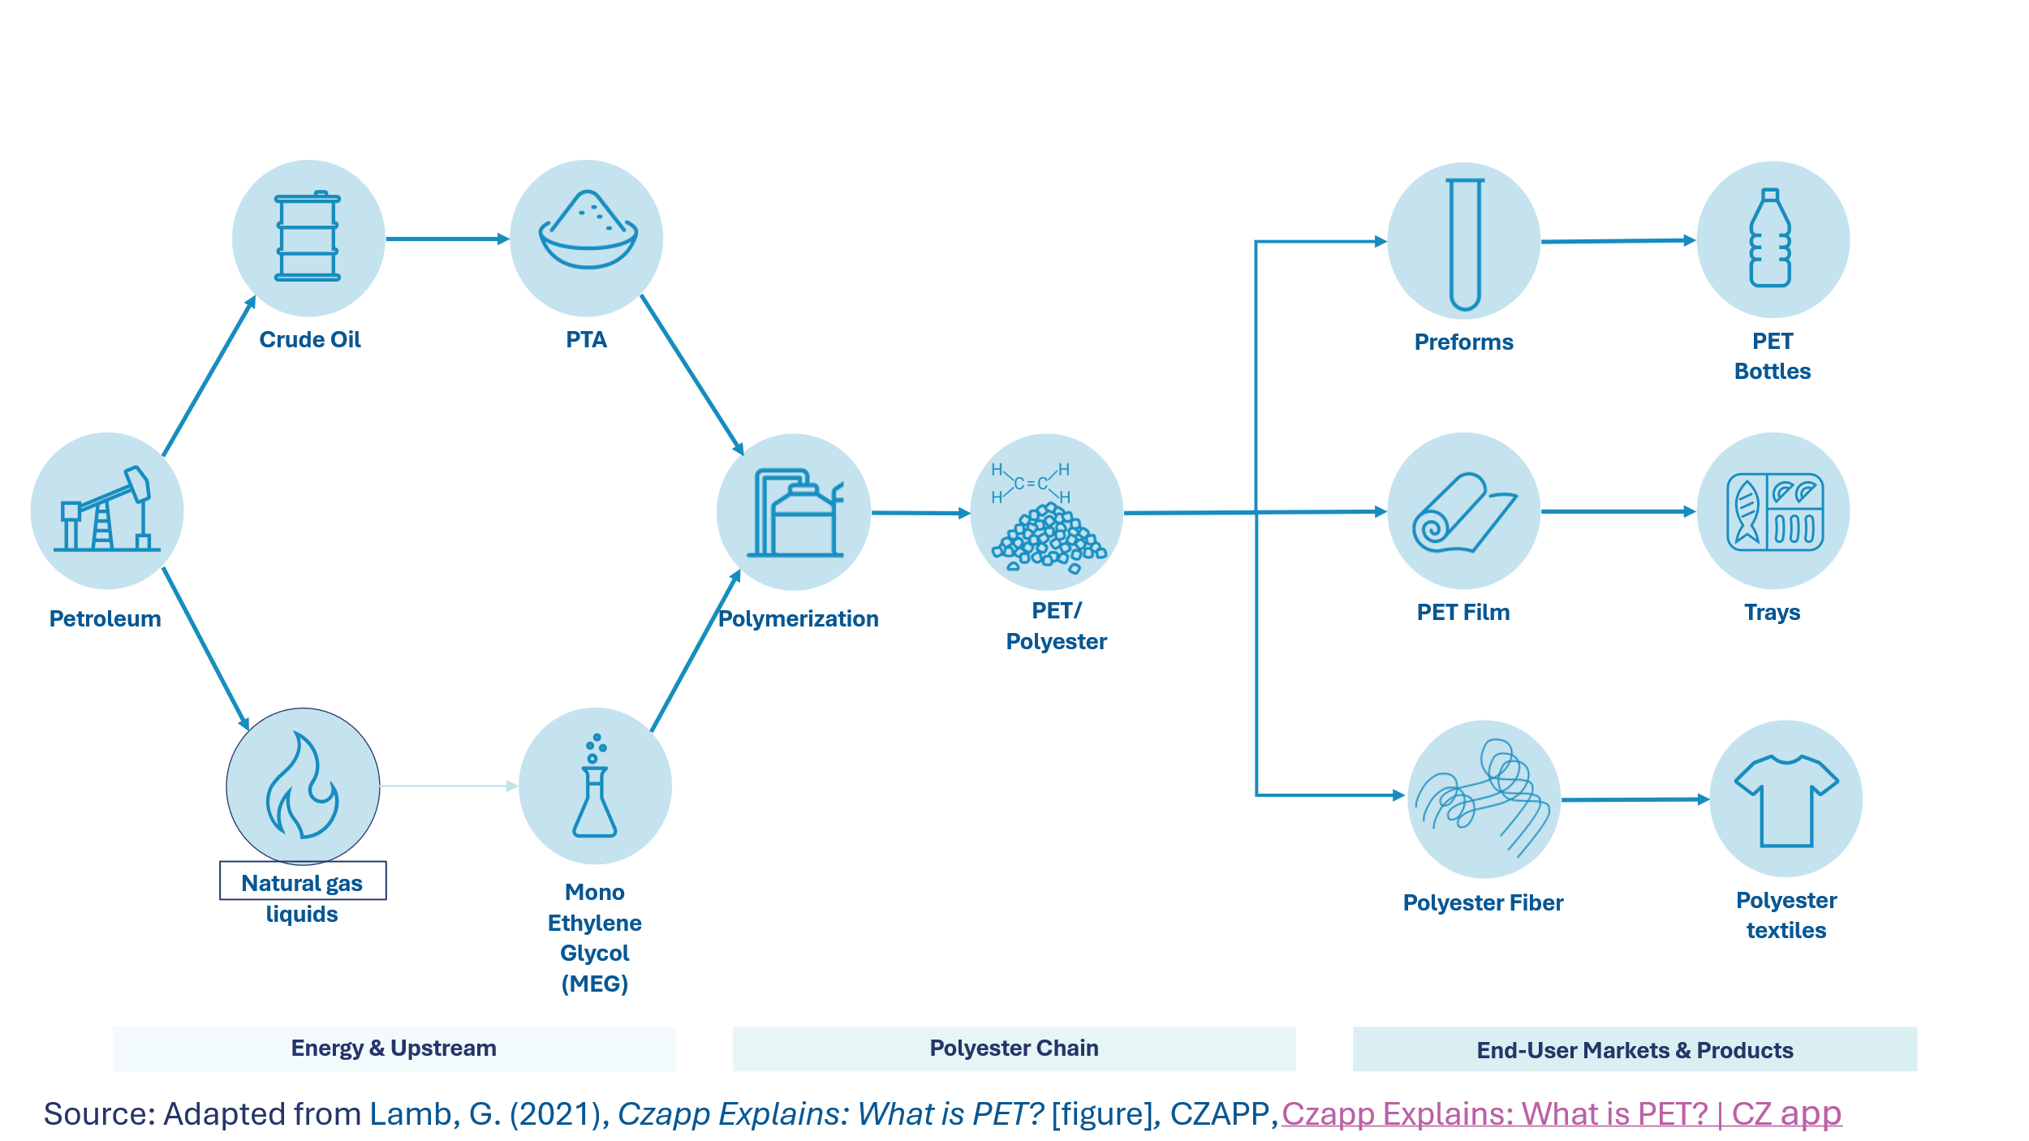

Intermediate feedstock markets for these chains often remain structurally oversupplied, particularly in Asia, where capacity additions have outpaced demand. Several third-party sources report that oversupply across these value chains has depressed margins while exports continue to grow despite weak domestic consumption. These dynamics are transmitted through other export-oriented economies which import low-cost inputs, expand production beyond domestic demand, and redirect output to the United States, reinforcing trade diversion and indirect import pressure. However, several feedstocks and raw materials for these value chains are not produced domestically and are not subject to the same excess capacity pressures so should be treated differently.

Chlorine/Chlor-alkali Value Chains

Chlorine and chlor-alkali also sit at the end of value chains used in domestic water treatment, building and construction, appliances, and printed circuited boards, among other sectors

Chart 7: Chlorine Value Chain

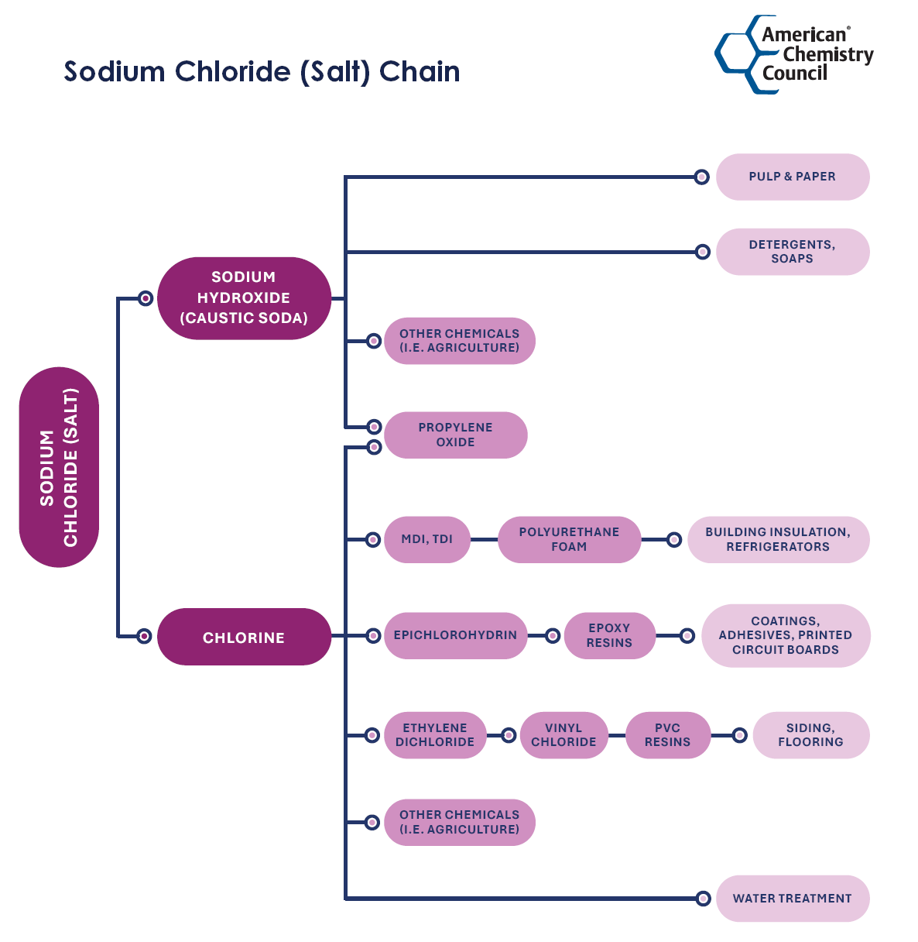
Source: American Chemistry Council, Chemical Chains, pg. 10
These value chains also face structural global excess capacity, driven largely by state supported investment in new capacity in Asia, and especially China, where producers often benefit from subsidized energy, finance, and industrial policies. Capacity additions equivalent to a large share of entire regional capacity occurred in just a few years, far outpacing demand growth in PVC, alumina, and pulp. Such supply driven production keeps high-cost assets elsewhere under constant price pressure and low operating rates. As domestic demand slows, this excess capacity is pushed into export markets displacing cost-reflective producers especially in the United States and Europe and creating conditions of unfair import competition. These dynamics place sustained downward pressure for chlorine, caustic soda, and downstream products undermining the ability of U.S. producers operating on commercial terms to maintain economically viable utilization rates and reinvest in U.S. based production. Like the previous example, several feedstocks and raw materials for these value chains are not produced domestically and are not subject to the same excess capacity pressures so should be treated differently.
ACC Recommends an Aligned and Reciprocal Approach on NME Practices with Like Minded Countries

The global chemical industry often functions as an integrated ecosystem in which complementary production assets, related party manufacturing, and collaborative R&D are tightly linked, including North America, other Western Hemisphere countries, and Europe. These inherent and transnational interdependencies mean that issues of excess capacity cannot be evaluated in isolation, as production capabilities are distributed across connected entities and shared innovation platforms. The chemicals and plastics sectors also encompass many different products, which are difficult to distinguish by description or HS classification. Past broad-brush attempts to place additional tariffs on all chemicals and plastics or target specific chemicals or plastics as part of other sectoral investigations on pharmaceuticals, steel and aluminum, or semiconductors, while may have delivered some benefits, have often unintentionally exposed U.S. chemical and plastic value chains to unfair trading practices.
To avoid similar unintended consequences from these investigations, we recommend a more aligned and reciprocal approach with other countries that share similar concerns about excess capacity on chemicals and plastics and that will help to open markets for our products and reduce unfair competition pressure. Based on the sectoral approach under the USMCA Annex on Chemical Substances, ACC has developed an updated sectoral proposal with additional tools focused on excess capacity and its causes, including addressing broader market distortions and trade diversion (“transshipment”) effects. Such a proposal could be included as a standalone understanding with other countries or as part of Agreements on Reciprocal Trade (ART) or similar agreements with other countries. This could also include elements from the Global Forum on Steel Excess Capacity as mentioned in this notice, extended to chemical and plastics.
ACC Recommends a Robust and Periodic Consultation Process with Industry Prior to any Proposed Tariffs
ACC recommends a strategic approach to any tariffs or defensive measures that are proposed prioritizing evidence of unfair trading practices while minimizing U.S. industry exposure. Any approach to tariffs or trade defense measures should ensure a focus on at risk materials while avoiding adding cost to materials, equipment and inputs used to make chemical products not available in the United States. Without such an approach, there is a significant risk of unintended consequences impacting U.S.-based production that relies on key import materials for value-added processing, both for domestic use and competitive exports. By taking a cooperative approach with key trading partners, this approach can also exclude impact to captive or intra-company shipments that sustain domestic production. This approach could build upon existing legislative approaches such as Representative Adrian Smith’s Miscellaneous Tariff Bill Reform Act and duty drawback to ensure robust supply chains and focus on addressing the genuine challenge of unfair import competition that distorts domestic value chains.
Conclusion
Prioritizing chemicals and plastics in these investigations demonstrates a positive impact of aligning trade with other Administration objectives in support of an America First approach that promotes innovative and advanced manufacturing, energy dominance, high-paying jobs, science-based regulations, and lower costs for U.S. producers and consumers. We respectfully ask that USTR and the Administration regularly work with ACC and its members when conducting these investigations and in developing any proposed actions.
If you have any questions about this submission, please contact Jason Bernstein, Director, International Trade and Supply Chain, at 202-249-6527 or at Jason_Bernstein@AmericanChemistry.com.

Link to chart on China Excess Production Capacity, Source: Roland Berger https://www.rolandberger.com/en/Insights/Publications/Global-chemicals-in-the-crosshairs-Why-China-s-overcapacity-demands-a-strategic.html
For more mapping of these value chains, please see pages 4, 5 and 6 of American Chemistry Council, Chemical Chains, https://www.americanchemistry.com/chemistry-in-america/data-industry-statistics/resources/chemical-chains-interactive-pdf
For more information about the chlorine value chain, see https://www.chlorine.org/wp-content/uploads/2017/08/chlorine-tree.pdf
For example, silicon, polysilicon, polysilicone are different products with different value chains
https://www.americanchemistry.com/better-policy-regulation/trade/resources/combined-north-american-chemisty-industry-proposal-on-usmca-review

